НТУУ “КПІ”

Кафедра Обчислювальної техніки

Лабораторна робота №3

з дискретної математики

“**Відношення множин**”

Виконав

ст. І курсу

ФІОТ, гр. ІО-01

Костенчук Володимир

Київ 2011

Варіант 30

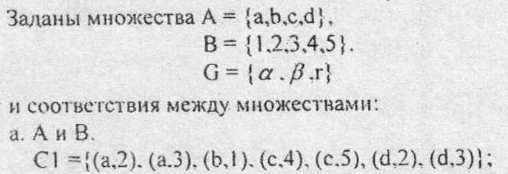

**C:\Documents and Settings\Администратор\Рабочий стол\13.jpg**

C:\Documents and Settings\Администратор\Рабочий стол\14.jpg

|  |  |  |  |  |
| --- | --- | --- | --- | --- |
| D1 | α | β | r |  |
| 1 | 0 | 1 | 1 |
| 2 | 1 | 0 | 1 |
| 3 | 0 | 0 | 1 |
| 5 | 1 | 1 | 0 |

|  |  |  |  |  |  |
| --- | --- | --- | --- | --- | --- |
|  | 1 | 2 | 3 | 5 |  |
| α | 0 | 1 | 0 | 1 |
| β | 1 | 0 | 0 | 1 |
| r | 1 | 1 | 1 | 0 |
|  | | | | |

|  |  |  |  |  |  |
| --- | --- | --- | --- | --- | --- |
|  | 1 | 2 | 3 | 5 |  |
| 1 | 1 | 1 | 1 | 1 |
| 2 | 1 | 1 | 1 | 1 |
| 3 | 1 | 1 | 1 | 0 |
| 5 | 1 | 1 | 0 | 1 |
| |  |  |  |  |  |  | | --- | --- | --- | --- | --- | --- | | C1 | 1 | 2 | 3 | 4 | 5 | | a | 0 | 1 | 1 | 0 | 0 | | b | 1 | 0 | 0 | 0 | 0 | | c | 0 | 0 | 0 | 1 | 1 | | d | 0 | 1 | 1 | 0 | 0 | | | | | |

|  |  |  |  |  |  |
| --- | --- | --- | --- | --- | --- |
|  | 1 | 2 | 3 | 4 |  |
| a | 1 | 1 | 1 | 1 |
| b | 1 | 1 | 1 | 1 |
| c | 1 | 1 | 0 | 1 |
| d | 1 | 1 | 1 | 1 |
|  | | | | |

1. **Блок-схема алгоритму:**

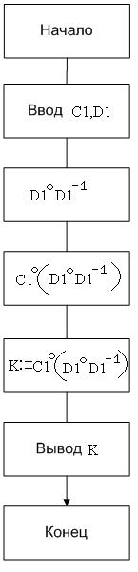

1. **Перевірка**

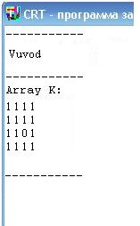

1. **Лістинг програми:**

PROGRAM Lab30;

USES Crt;

TYPE TIndex = 1..N;

TZIndex = 0..N;

TVector = ARRAY[TIndex] OF 0..1;

TArray = ARRAY[TIndex, Tindex] OF 0..1;

TMatrix = ARRAY[TIndex, Tindex] OF 0..N;

VAR R, R_1: TArray;

K: TMatrix;

PROCEDURE Init;

VAR l, NR: byte;

i, j: TIndex;

BEGIN

FOR i := 1 TO N DO

FOR j := 1 TO N DO

R[i, j] := 0;

Writeln('Input number of elements of ratio R:');

Readln(NR);

Writeln('Input elements of ratio R:');

FOR l := 1 TO NR DO

BEGIN

Readln(i, j);

R[j, i] := 1

END;

Writeln('Array R:');

FOR i := 1 TO N DO

BEGIN

FOR j := 1 TO N DO Write(R[i, j], ' ');

Writeln

END;

Readln

END;

PROCEDURE d1d1;

VAR temp: boolean;

i, j: TIndex;

pr1R, pr2R: TVector;

BEGIN

FOR i := 1 TO N DO

BEGIN

pr1R[i] := 0;

pr2R[i] := 0

END;

FOR i := 1 TO N DO

BEGIN

temp := false;

FOR j := 1 TO N DO IF R[j, i] = 1 THEN temp := true;

IF temp THEN pr1R[i] := 1

END;

FOR i := 1 TO N DO

BEGIN

temp := false;

FOR j := 1 TO N DO IF R[i, j] = 1 THEN temp := true;

IF temp THEN pr2R[i] := 1

END;

Write('pr1R = { ');

FOR i := 1 TO N DO IF pr1R[i] = 1 THEN Write(i,' ');

Writeln('}');

Write('pr2R = { ');

FOR i := 1 TO N DO IF pr2R[i] = 1 THEN Write(i,' ');

Writeln('}');

Readln

END;

PROCEDURE c1d1;

VAR i, j: TIndex;

BEGIN

FOR i := 1 TO N DO

FOR j := 1 TO N DO

R_1[i, j] := R[j, i];

Writeln('Array R_1:');

FOR i := 1 TO N DO

BEGIN

FOR j := 1 TO N DO Write(R_1[i, j], ' ');

Writeln

END;

Readln

END;

PROCEDURE Composition;

VAR l: byte;

i, j: TIndex;

S: TZIndex;

BEGIN

FOR i := 1 TO N DO

FOR j := 1 TO N DO

BEGIN

S := 0;

FOR l := 1 TO N DO S := S + R[i, l]*R_1[l, j];

K[i, j] := S

END;

Writeln('Array K:');

FOR i := 1 TO N DO

BEGIN

FOR j := 1 TO N DO Write(K[i, j], ' ');

Writeln

END;

Readln;

FOR i := 1 TO N DO

FOR j := 1 TO N DO

IF K[i, j] > 1 THEN K[i, j] := 1;

Writeln('Array K:');

FOR i := 1 TO N DO

BEGIN

FOR j := 1 TO N DO Write(K[i, j], ' ');

Writeln

END

END;

BEGIN

Init;

D1d1;

C1d1;

Composition

END.